Mathematics Year 7 Name:……..…………............. Date:………
 Yr7 Mini Test 1 2018
/37

This test is Calculator Free
Marks Available: 37 marks Time Allowed: 30 minutes

- (6 marks)
Show using < and > which number is bigger;
- 9 ___ 10 | - -5 ___ 5
- -22 ___ -32 | - 0 ___ -4
- 3 ___ -2 | - -16 ___ -25

- (4 marks)
Put the following in ascending order (smallest to largest).

- -5, 4, -2, 7, 0, 8, -9, 3
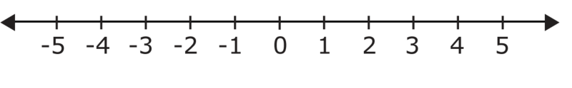
-10 0 10

- (6 marks)
Solve the following
- $5 + 7 =$ _____ | - $-6 + 2 = _____$
- $9 – 12 = ______$ | - $-12- -6 = _____$
- $-15 + -3 = ______$ | - $-3 + -2- -5 = _____$

- (2, 2, 3 = 7 marks)
Solve the following

- $5+4×3=$

- $15÷5×7=$

- $\left(6- -3\right)×4+2=$

- (1 marks)
Insert any brackets to make the following correct

$$4 + 5 × 2 - 1 = 17$$

- (6 marks)
Write whether these equations are TRUE or FALSE
- $6+7=7+6$  ____________ | - $10-4=4-10$  ____________
- $\left(6+8\right)×5=5×6+5×8$  ____________ | - $14÷2=2÷14$  ____________
- $\left(7-5\right)-3 =7-(5-3)$  ____________ | - $\left(3+12\right)+2=3+(12+2)$  ____________

- (1 mark)
CIRCLE which of the following best describe (5 + 4) + 6 = (6 + 4) + 5
- $Commutative Law$ | - $Distributive Law$
- $Associative Law$ | - $These laws don^{'}tapply to subtraction$

- (2 marks)
Circle which of the following is the best way to multiply 138 x 42 numbers AND explain why you chose that?

140 x 40 (138 x 40) + (138 x 2)

- (2 marks)
A farmer lowers a bucket from the top of a 1m high well using a 10m rope attached to the handle. If she lowers the whole length of rope, how far below the ground does the bucket reach?

- (2 marks)
The temperature at sunrise in Russia was -5°C. During the day the temperature rose 9°C and then dropped by 12°C at 7pm. What is the temperature at 7pm?

End of Test

